College of Medicine, Division of Social Accountability, 2019 Community Reciprocity Fund
Title: Saskatoon Food Bank Garden Patch’s Play Area Brings Children Outside to Explore and Grow
Throughout July and August of 2019 volunteers at the Saskatoon Food Bank & Learning Centre created a play space at the Garden Patch with support from the College of Medicine, Division of Social Accountability’s Community Reciprocity Fund. A beehive climbing structure is a focal point with colourfully decorated themed picture boards (plywood character face-cutouts) surrounding the space. A bright rainbow bridge welcomes people into the semi enclosed and safe area. Child sized gardening tools and buckets are paired with a donated play kitchen and toys. There is enough here to entertain our children while we, parents, are able to work and learn in the garden. Children have their own planting beds with special sensory plants that invite curiosity and exploration.
Every year the Saskatoon Food Bank & Learning Centre (SFBLC) Garden Patch engages nearly 1,500 individuals who donate around 3,000 hours of their time to grow fresh produce for emergency food baskets. Achieving a food secure community requires providing emergency food for the short term while working to reduce barriers facing people who are food insecure. This is where community engagement and education are also critical to the success of our work to support the physical and mental health of underserved and marginalized communities. As one of Saskatoon's premier Urban Agriculture sites, the SFBLC Garden Patch continuously seeks ways to both forge and support authentic partnerships with those organizations with similar missions, like the College of Medicine.
In a 2019 survey of community members accessing SFBLC's emergency food baskets, however, a lack of childcare was identified as a key barrier to participation in our gardening programs. To help address this, the SFBLC built a play area at the Garden Patch where young children (old enough to not require constant supervision) can safely and creatively occupy their time while their parents are attending workshops and participating in other short gardening activities (max. 60-90 minutes). In our world now so connected to technology the Garden Patch provides a space for both adults and children to unplug. Outdoor play is essential for physical and mental growth paired with the mental health support and expanded love of good food found in a garden, the Garden Patch is perfectly aligned to support both child and parent.

The project was implemented in three phases. First the Garden Patch team talked to local experts in building outdoor play areas. Then we showed our plans to children who come to the Garden Patch to get their feedback. This resulted in the final plan. During the second phase, staff and volunteers worked together to clear the site, dig a “flower river”, and build a stump path, the rainbow bridge, and the play hive. Then we designed and painted the face-in-the-holes. Garden beds were built along the exterior fence, painted, and filled with soil and compost. Annuals and perennials were planted throughout the children’s garden including: sage, mint, lemon verbena, thyme, rosemary, lavender, and oregano. At this point children started playing in the garden. Parents who were not already volunteers also began visiting the garden to play, which was an unanticipated outcome of the garden. Tools, toys, and a play hut were added to the garden at this point. An early success of the garden happened at the Community BBQ. During that event we held a puppet show. Over 50 children played in the garden and we were rewarded by seeing that they played in the space the way we dreamed they would.

By creating a space that is fun and welcoming to children we anticipate many more opportunities to engage with families in this space. We hope this project will assist us as we work toward a food secure community.

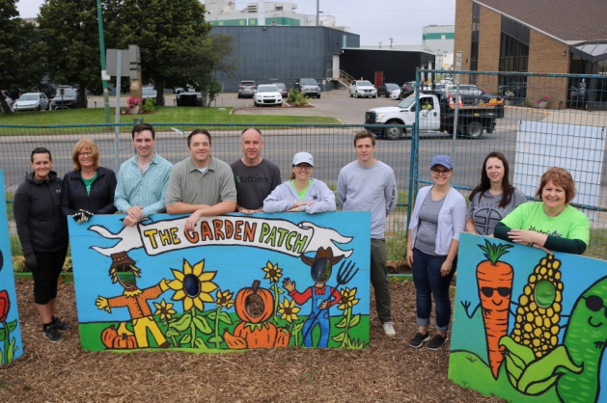
Picture Boards (face-cutouts)

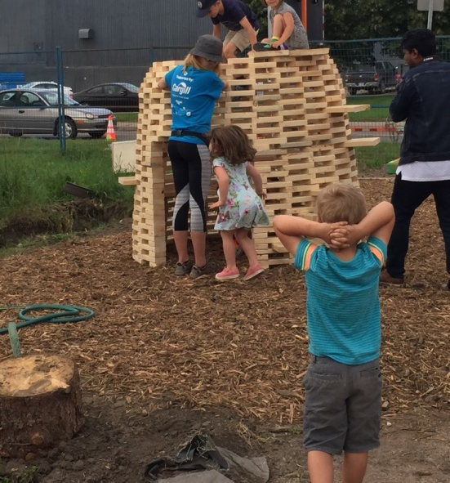

Play structure tested and approved before painting.

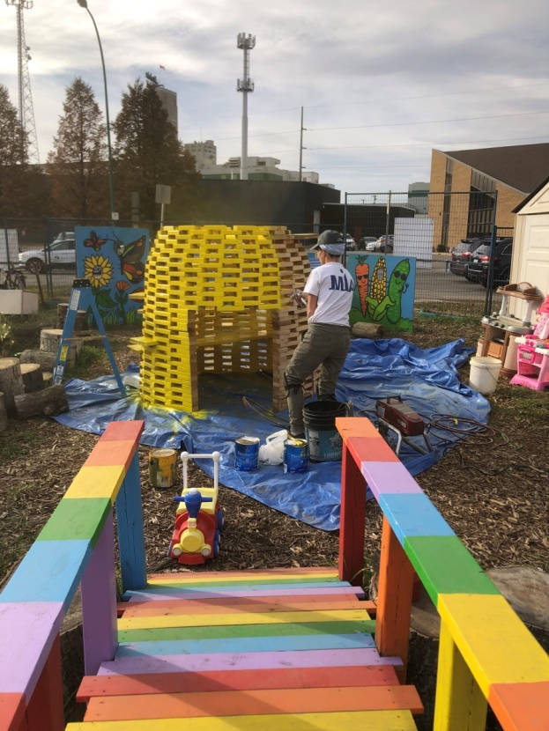
Painting the beehive climbing structure bright yellow. The rainbow bridge, cut log seating/climbing path and donated toys complete the area.

